**Gravity Bomb *GBU-57A/B***

Note: The shape being dropped from the Edwards AFB B-52 test aircraft in one of the below photos is not the GBU-57, but rather an older style gravity weapon.  File photo for demo purposes I guess.  Henry C.

*GBU-57A/B* The Pentagon is accelerating by three years its plans for a super bunker buster, the GBU-57A/B or Massive Ordnance Penetrator (MOP), a powerful new bomb aimed squarely at the underground nuclear facilities of Iran and North Korea. The gargantuan bomb is longer than 11 persons standing shoulder-to-shoulder or more than 20 feet base to nose and weighs over 15 tons (31,862 pounds). Some 18 percent of its total weight is comprised of explosives. The GBU-57A/B MOP is so immense it can only be carried by either a B-52 or a B-2A Stealth bomber.

The weapons explosive power is 10 times greater than its predecessor, the BLU-109. Moreover, the GBU-57A/B MOP is one third heavier than the MOAB dubbed the ***Mother of All Bombs***. This super buster all started with a break-through by the Raytheon Company when it developed and tested a new conventional warhead technology to defeat hardened and deeply buried bunkers. The new technology, called Tandem Warhead System, consists of a shaped-charge precursor warhead combined with a follow-through penetrator explosive charge. A small MOP prototype was exploded deep under the rugged mountains of the White Sands Missile Range in New Mexico in the caverns of the little-known Weapons of Mass Destruction National Test beds.

The slender orange-colored MOP small prototype was vertically hung, nose down, just inches from the floor of a narrow cavern and then detonated. During the test, the newly developed 1,000-pound-class test warhead set a record when it punched through 19 feet, 3 inches of a 20-foot, 330-ton, steel rod-reinforced concrete block rated at 12,600 pounds per square inch compressive strength. In fewer than 10 milliseconds, the explosion delivered into the target more than 110 million foot-pounds of energy via a high-velocity jet of molten metal.

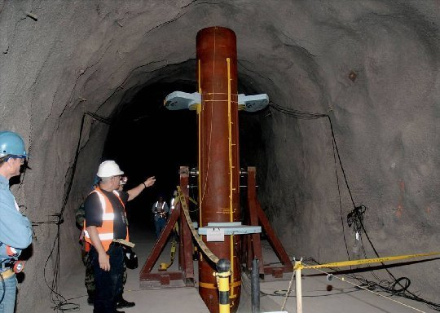

Simultaneously, the Air Force contracted to have an extremely accurate GPS guidance system developed for the MOP; a system more accurate than those deployed in Iraq. It is believed that the CEP (Circle of Error Probably) for the new system is less than five meters.

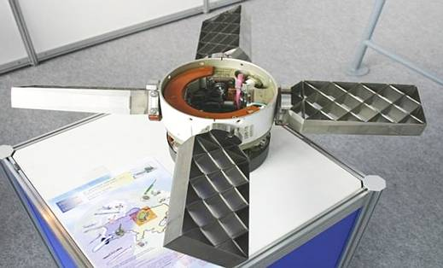

Guided by the new precision GPS system, the MOP can penetrate an unprecedented 200 feet down before exploding with devastation into an underground bunker, such as those buried in Iran and North Korea currently used to shield rogue nuclear programs.

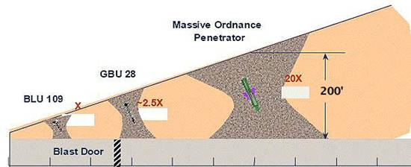

A test of the full sized prototype was conducted using a B-52 for the test drop. The prototype weapon met each and every flight, guidance, penetration and detonation requirements.

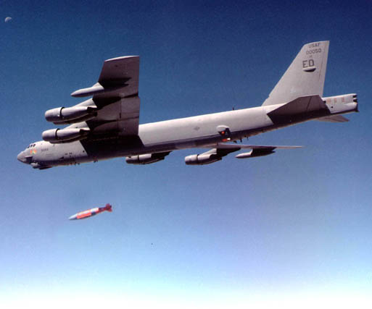

*(Older version being dropped)*

Its sheer explosive power was demonstrated in the test. By the end of 2007, a full-size dummy mock-up of the eventual GBU-57A/B MOP was loaded into the bay of a B2 at Whiteman Air Force Base in Missouri. A member of the 509th Maintenance Group personally handling the bomb remarked, "I couldn't help but notice how enormous the bomb was hanging in the weapons bay".

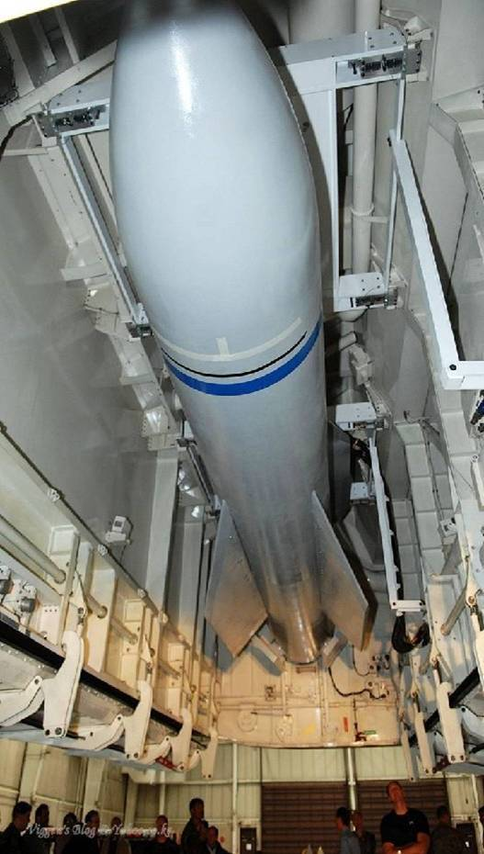

A crash program was then approved to modify B-2A Stealth bombers to carry a payload oftwo GBU-57A/B MOP bombs. The speed and urgency comes at a time when Iran, NATO and Israel are approaching a denouement over Tehran's nuclear ambitions, its development of long-range, multi-stage missiles and a new awareness that it is clearly developing a nuclear bomb. The Air Force Research Laboratory (AFRL) at Wright Patterson Air Force Base in Ohio and the AFRLs Munitions Directorate and the Air Armament Center, both headquartered at Eglin Air Force Base in Florida, are now rushing to modify the bay of a radar-evading B-2A Stealth Bomber to deliver the bomb.

A collage of private sector subcontractors is also working on effort, from Stealth bomber manufacturer Northrop-Grumman to Boeings Phantom Works, maker of the bomb itself and prime contractor for the entire project. The Defense Threat Reduction Agency in Virginia has been coordinating among the various air force groups from the beginning. Thus, we will now have a non-nuclear weapon capable of deep penetration and massive explosive power.

**GBU-57 A/B**

